25.12.8 Editors - Properties Editor - Object Data Tab - Armature Object
Detailed table of content 1
Skeleton panel 4
Position 4
Layers 4
Protected Layers 4
Bone Groups panel 5
List View 5
Add / Remove 5
Bone Group Specials 5
Move Bone Group Up / Down 5
Color Set 6
Assign 6
Remove 6
Select 6
Deselect 6
Pose Library Panel 6
Pose Library property 6
List View 7
Poselib Add Pose 7
Apply Pose 8
Sanitize Action 8
Move Up / Down 8
Motion Paths panel 8
Workflow 8
Paths Type 9
Frame Range Start 9
End 9
Step 9
Bone Cache from 9
To 9
Calculate / Update Paths 9
Display 10
Viewport Display panel 10
Display As 10
Names 11
Axes 11
Shapes 11
Group Colors 11
In Front 11
Inverse Kinematics panel 12
IK Solver 12

Detailed table of content
Detailed table of content
Detailed table of content 1
Skeleton panel 4
Position 4
Layers 4
Protected Layers 4
Bone Groups panel 5
List View 5
Drag Handler 5
Search Field 5
Invert 5
Sort by Name 5
Add / Remove 5
Bone Group Specials 5
Sort Bone Groups 5
Move Bone Group Up / Down 5
Color Set 6
Bone Color Set 6
Assign 6
Remove 6
Select 6
Deselect 6
Pose Library Panel 6
Pose Library property 6
Data Browser 6
Name 7
Number of users 7
Fake User 7
New Pose Library 7
Remove Pose Library 7
List View 7
Drag Handler 7
Search Field 7
Invert 7
Sort by Name 7
Poselib Add Pose 7
Add New 7
Add New (Current Frame) 7
Replace Existing 8
Apply Pose 8
Sanitize Action 8
Move Up / Down 8
Motion Paths panel 8
Workflow 8
Paths Type 9
In Range 9
Around Frame 9
Frame Range Start 9
End 9
Step 9
Bone Cache from 9
To 9
Calculate / Update Paths 9
Start 9
End 9
Bake Location 9
Display 10
Frame Numbers 10
Keyframes 10
+ Non-Grouped Keyframes 10
Keyframe Numbers 10
Lines 10
Thickness 10
Custom Color 10
Viewport Display panel 10
Display As 10
Octahedral 10
Stick 11
B-Bone 11
Envelope 11
Wire 11
Names 11
Axes 11
Shapes 11
Group Colors 11
In Front 11
Inverse Kinematics panel 12
IK Solver 12
Standard 12
iTaSC 12
Mode 12
Animation 12
Precision 12
Iterations 12
Solver 12
SDLS 12
DLS 13
Damping Max 13
Damping Epsilon 13
Simulation 13
Reiteration 13
Never 13
Initial 13
Always 13
Precision 13
Iterations 13
Solver 14
SDLS 14
Feedback 14
Max Velocity 14
DLS 14
Feedback 14
Max Velocity 14
Damping Max 15
Damping Epsilon 15
Auto Step 15
Steps 15
Min 15
Max 15

Skeleton panel

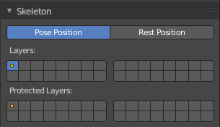
This panel allows you to turn the display for bone and armature layers on and off.

Position
Switch between Pose Position and Rest Position.

Pose position shows the armature in the currently posed state.
Rest Position shows the armature in the rest position. In Rest Pose mode there is no posing possible.

Layers
Each armature has 32 Armature layers. They allow you to organize your armature.

The orange dot means there is a bone or a armature in this layer. Blue means this layer is visible. To set a layer to visible or hidden simply click at it. To make more than one layer visible or hidden, hold down shift and click.

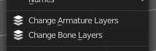
To move a bone or an armature to another layer go either to pose mode or to edit mode.
Select the bones or the armature that you want to move to another layer.
In Pose mode go to Pose menu, and choose Change Bone Layer. Or Change Armature Layer.
In Edit mode go to Armature menu, and choose Change Bone Layer. Or Change Armature Layer.
In the menu that comes up choose the slot that you want to move the bone or armature to.
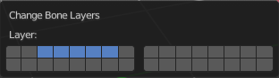
Bones can be at more than one layer. Hold down shift and click to add the bone or armature to several layers.

Protected Layers
Protected layers has to do with linked blend files with armatures. You can lock a given bone layer for all proxies of your armature. This means bones in this layer will not be editable. To do so, in the Skeleton panel, Ctrl-LMB click on the relevant button, the layer lock will be enabled. And the bone will not be editable in other blend files where it is linked to.

Protected layers in proxy are restored to proxy settings on file reload and undo.

Note that this feature is deprecated. Proxies will be replaced by Library Overrides soon.

Proxies are the historical way in Blender to allow some local editing of linked data-blocks. This is mostly aimed at character animation. One of their most important restrictions is that you can only have one proxy of any linked object in a given blend-file.

Bone Groups panel

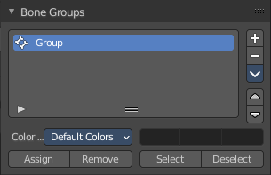
This panel allows the creation, deletion and editing of Bone Groups.

Bone Groups can be used for selection. Or to assign a color theme to a set of bones. For example to color the left parts of the rig as blue and right parts as red.

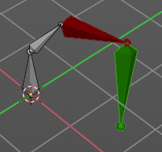
Bone groups is a Pose Mode feature. The controls will be disabled in Object and Edit mode.

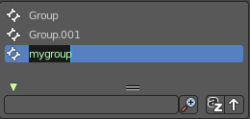
List View
The List view with the bone groups. Double clicking at the name makes it editable.

Drag Handler
The two vertical lines at the end is a handler with which you can expand the list.

Search Field

You can expand a search field at the bottom of the list. Type in your term and hit enter to filter for your term.

Invert
Exclude the search term instead of searching for it.

Sort by Name
Sort the List by name.

Add / Remove
Add or remove a bone group.

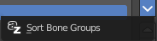
Bone Group Specials

Sort Bone Groups
Sort the bone groups by their names in ascending order.

Move Bone Group Up / Down
Move the selected bone group up or down in the list.

Color Set
Use a color theme for your bone group.

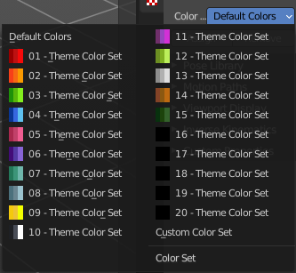
Bone Color Set
A set of predefined bone color sets. Each set is made of three colors.

Normal
The first color field is the color of unselected bones.
Selected
The second color field is the outline color of selected bones.
Active
The third color field is the outline color of the active bone.

The custom color set is editable. The other color sets are fixed.


Assign
Assigns the selected bones to the active bone group. Note! A bone can only belong to one group.

Remove
Removes the selected bones from the active bone group.

Select
Selects the bones in the active bone group.

Deselect
Deselects the bones in the active bone group.

Pose Library Panel
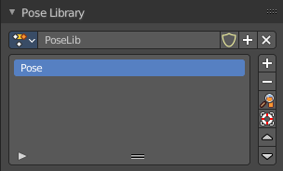
Create, apply, and manage armature poses.
Poses are made of posed armatures. Just what is selected gets stored in a pose. This can be the whole armature. Or just one bone.
Pose Libraries are saved to Actions. They are not generally used as actions, but can be converted to and from.
You need to be in pose mode to use Pose libraries.
Pose libraries can be reused at other armatures if they match the bone hierarchy. Not matching hierarchy can lead to errors.

Pose Library property

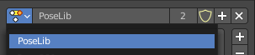
Data Browser
A Menu to browse the available pose libraries.

Name
The name of the pose library. A double left click makes the name editable.

Number of users
The number of users for this library.

Fake User
Save this library with the blend file even if it has no user.

New Pose Library
Create a new pose library.

Remove Pose Library
Removes the pose library from the armature. Note that it is still available in the data browser as long as it has users, or as long as the blend file is not reloaded.

List View
A list of the available poses in this pose library. Double clicking at the name makes it editable.

Drag Handler
The two vertical lines at the end is a handler with which you can expand the list.

Search Field
You can expand a search field at the bottom of the list. Type in your term and hit enter to filter for your term.

Invert
Exclude the search term instead of searching for it.

Sort by Name
Sort the List by name.

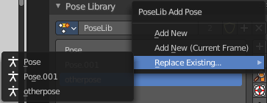
Poselib Add Pose
Add a new pose, using the currently selected bones.

Add New
Adds a new pose to the active Pose Library with the current pose of the armature.

Add New (Current Frame)
Will add a pose to the Pose Library based on the current frame selected in the Timeline. In contrast to Add New and Replace Existing which automatically allocate a pose to an action frame.

Replace Existing
Replace an existing pose in the active Pose Library with the current pose of the armature.

Apply Pose
Applies the active pose to the selected pose bones.

Sanitize Action
Sanitize Action is used to convert an Action to a Pose Library. A pose is added to the Pose Library for each frame with keyframes.

Move Up / Down
Moves the pose up or down in the list.

Motion Paths panel
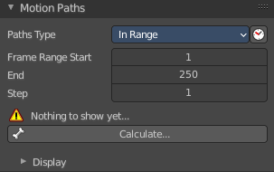
Motion paths allows you to visualize motion paths of animated bones.

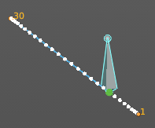
Workflow
Select the bones that you want to calculate a path for. Note that they should have an animation. No animation, no motion path.
Click at the Calculate button.
When you change the animation then you might need to update the paths.

To remove the paths, click at the X button at the Update paths button.

Note! Remember that only selected bones and their paths are affected by these actions!

The paths are shown in a light shade of gray for unselected points, and a slightly blueish gray for selected ones. Around the current frame a glow indicate the direction of movement: blue towards future frames and green towards the past. Each frame is displayed by a small white dot on the paths.

The paths are automatically updated when you edit your poses/keyframes, and they are also active during animation playback. Playing the animation affects the paths only when the Around Current Frame option is enabled.

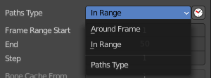
Paths Type

In Range
Display paths of points within specified range.

Around Frame
Display paths of points within a fixed number of frames around the current frame. When you enable this button, you get paths for a given number of frames before and after the current one (again, as with ghosts).

Frame Range Start
The start frame for the paths calculation. (not for Around Current Frame Onion-skinning method).

End
The end frame for the paths calculation. (not for Around Current Frame Onion-skinning method).

Step
Display one point for every n frames on the path.

Bone Cache from
The start frame of the range in which motion paths are shown. You cannot modify this range without deleting the motion path first.

To
The end frame of the range in which motion paths are shown. You cannot modify this range without deleting the motion path first.

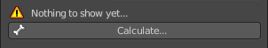
Calculate / Update Paths
Calculate Paths will create a new motion path in cache. It will open a popup where you can adjust the settings.

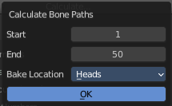
Start
The start frame of the path.

End
The end frame of the path.

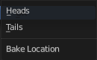
Bake Location
Where to display the path. At the heads of the bones or at the tail of the bones.
If a path has already been calculated, Update Paths will update the path shape to the current animation. To change the frame range of the calculated path, you need to delete the path and calculate it again.

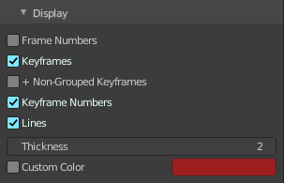
Display

Frame Numbers
Show a small number of the corresponding frame next to each frame dot on the path.

Keyframes
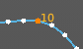
Show the keyframes at the path, with frame number.

+ Non-Grouped Keyframes
For bone motion paths, it searches the whole Action for keyframes instead of in groups with matching name only (this is slower).

Keyframe Numbers
When enabled, you will see the numbers of the displayed keyframes, so this option is obviously only valid when Show Keys is enabled.

Lines
Toggles whether the lines between the points are shown.

Thickness
Customizable thickness for the lines.

Custom Color
Custom color for the lines.

Viewport Display panel
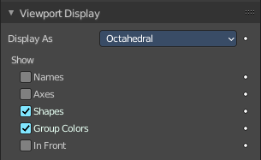
Display options for bones.

Display As
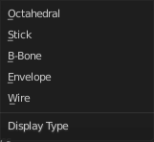
How the bones are displayed in the 3D Viewport.

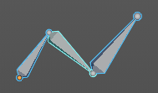
Octahedral
Bones are displayed as a octahedral. With a thick and a thin end.

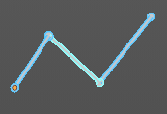
Stick
Bones are displayed as a stick.

B-Bone
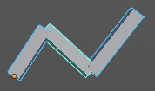
Bones are displayed as a cuboid. This bone display type also allows to display bendy bones subdivisions.
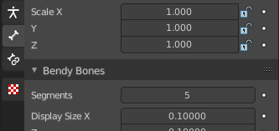
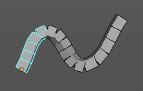

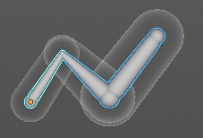
Envelope
Bones are displayed with its envelopes. The bone deformation influence areas.

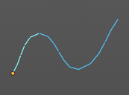
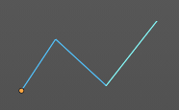
Wire
Bones are displayed as thin wire lines. This bone display type also allows to display bendy bones subdivisions.

Names
Displays the name of each bone.

Axes
When enabled, the (local) axes of each bone are displayed (only relevant for Edit Mode and Pose Mode).

Shapes
When enabled, the default standard bone shape is replaced, in Object Mode and Pose Mode, by the shape of a chosen object (see Shaped Bones for details).

Group Colors
Display Bone Group colors to color the bone, if a color set is assigned in the Bone Groups panel.

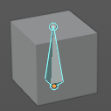
In Front
Display the armature always in front of mesh objects, even when they are inside.

Inverse Kinematics panel
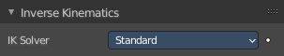
Inverse Kinematics settings.

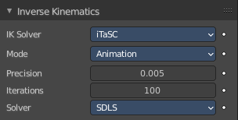

IK Solver
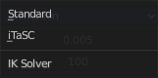
The available Ik solver solution. Standard and iTaSC.

Standard
The standard Ik solver. It has no further settings.

iTaSC
iTaSC stands for instantaneous Task Specification using Constraints. It is a generic multi-constraint IK solver. It has more settings and works a bit different than the standard IK solver.

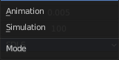
Mode
The itasc mode. Animation or Simulation.

Animation
In Animation mode, iTaSC operates like an IK solver: it is stateless and uses the pose from F-curves interpolation as the start pose before the IK convergence. The target velocity is ignored and the solver converges until the given precision is obtained. Still the new solver is usually faster than the old one and provides features that are inherent to iTaSC: multiple targets per bone and multiple types of constraints.

Precision
The maximum variation of the end effector between two successive iterations at which a pose is obtained that is stable enough and the solver should stop the iterations. Lower values means higher precision on the end effector position.

Iterations
The upper bound for the number of iterations.

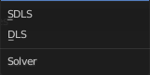
Solver
Select the inverse Jacobian solver that iTaSC will use.

SDLS
Computes the damping automatically by estimating the level of ‘cancellation’ in the armature kinematics. This method works well with the Copy Pose constraint but has the drawback of damping more than necessary around the singular pose, which means slower movements. Note that this is only noticeable in Simulation mode.

The SDLS solver does not work together with a Distance constraint. You must use the DLS solver if you are going to have a singular pose in your animation with the Distance constraint.

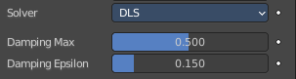
DLS
Computes the damping manually. Damping and Epsilon must be tuned for each armature. You should use the smallest values that preserve stability.

Damping Max
Maximum amount of damping. Smaller values means less damping, hence more velocity and better precision but also more risk of oscillation at singular pose. 0 means no damping at all.

Damping Epsilon
Range of the damping zone around singular pose. Smaller values means a smaller zone of control and greater risk of passing over the singular pose, which means oscillation.

Simulation
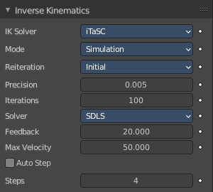
The Simulation mode estimates the target’s velocity, operates in a ‘true time’ context, ignores rotation from keyframes (except via a joint rotation constraint) and builds up a state cache automatically.

Reiteration

Never
The solver starts from the rest pose and does not reiterate (converges) even for the first frame. This means that it will take a few frames to get to the target at the start of the animation.
Never will grey out most of the options.

Initial
The solver starts from the rest pose and re-iterates until the given precision is achieved, but only on the first frame (i.e. a frame which doesn’t have any previous frame in the cache). This option basically allows you to choose a different start pose than the rest pose and it is the default value. For the subsequent frames, the solver will track the target by integrating the joint velocity computed by the Jacobian solver over the time interval that the frame represents. The precision of the tracking depends on the feedback coefficient, number of substeps and velocity of the target.

Always
The solver re-iterates on each frame until the given precision is achieved. This option omits most of the iTaSC dynamic behavior: the maximum joint velocity and the continuity between frames is not guaranteed anymore in compensation of better precision on the end effector positions. It is an intermediate mode between Animation and real-time Simulation.

Precision
The maximum variation of the end effector between two successive iterations at which a pose is obtained that is stable enough and the solver should stop the iterations. Lower values means higher precision on the end effector position.

Iterations
The upper bound for the number of iterations.

Solver
Select the inverse Jacobian solver that iTaSC will use.

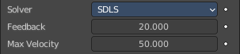
SDLS
Computes the damping automatically by estimating the level of ‘cancellation’ in the armature kinematics. This method works well with the Copy Pose constraint but has the drawback of damping more than necessary around the singular pose, which means slower movements. Note that this is only noticeable in Simulation mode.

The SDLS solver does not work together with a Distance constraint. You must use the DLS solver if you are going to have a singular pose in your animation with the Distance constraint.

Feedback
Coefficient on end effector position error to set corrective joint velocity. The time constant of the error correction is the inverse of this value. However, this parameter has little effect on the dynamic of the armature since the algorithm evaluates the target velocity in any case. Setting this parameter to 0 means ‘opening the loop’: the solver tracks the velocity but not the position; the error will accumulate rapidly. Setting this value too high means an excessive amount of correction and risk of instability. The value should be in the range 20-100. Default value is 20, which means that tracking errors are corrected in a typical time of 100-200 ms. The feedback coefficient is the reason why the armature continues to move slightly in Simulation mode even if the target has stopped moving: the residual error is progressively suppressed frame after frame.

Max Velocity
Indicative maximum joint velocity in radian per second. This parameter has an important effect on the armature dynamic. Smaller value will cause the armature to move slowly and lag behind if the targets are moving rapidly. You can simulate an inertia by setting this parameter to a low value.

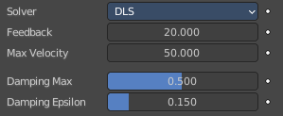
DLS
Computes the damping manually. Damping and Epsilon must be tuned for each armature. You should use the smallest values that preserve stability.

Feedback
Coefficient on end effector position error to set corrective joint velocity. The time constant of the error correction is the inverse of this value. However, this parameter has little effect on the dynamic of the armature since the algorithm evaluates the target velocity in any case. Setting this parameter to 0 means ‘opening the loop’: the solver tracks the velocity but not the position; the error will accumulate rapidly. Setting this value too high means an excessive amount of correction and risk of instability. The value should be in the range 20-100. Default value is 20, which means that tracking errors are corrected in a typical time of 100-200 ms. The feedback coefficient is the reason why the armature continues to move slightly in Simulation mode even if the target has stopped moving: the residual error is progressively suppressed frame after frame.

Max Velocity
Indicative maximum joint velocity in radian per second. This parameter has an important effect on the armature dynamic. Smaller value will cause the armature to move slowly and lag behind if the targets are moving rapidly. You can simulate an inertia by setting this parameter to a low value.

Damping Max
Maximum amount of damping. Smaller values means less damping, hence more velocity and better precision but also more risk of oscillation at singular pose. 0 means no damping at all.

Damping Epsilon
Range of the damping zone around singular pose. Smaller values means a smaller zone of control and greater risk of passing over the singular pose, which means oscillation.

Auto Step
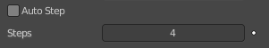
Let the solver set how many substeps should be executed for each frame.

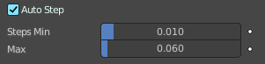
A substep is a subdivision on the time between two frames for which the solver evaluates the IK equation and updates the joint position. More substeps means more processing but better precision on tracking the targets. The auto step algorithm estimates the optimal number of steps to get the best trade-off between processing and precision. It works by estimation of the nonlinearity of the pose and by limiting the amplitude of joint variation during a substep. It can be configured with the min and max parameters.

Steps
Auto Step off. Choose a fixed number of substeps with this parameter. Substep should not be longer than 10 ms, which means the number of steps is 4 for a 25 fps animation. If the armature seems unstable (vibrates) between frames, you can improve the stability by increasing the number of steps.

Min
Auto Step on. Proposed minimum substep duration (in second). The auto step algorithm may reduce the substep further based on joint velocity.

Max
Auto Step on. Maximum substep duration (in second). The auto step algorithm will not allow substep longer than this value.

